**Ministry of Education and Training**

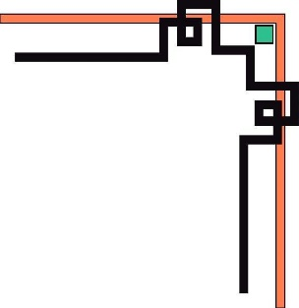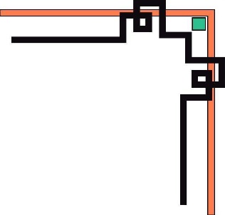

**HO CHI MINH UNIVERSITY OF TECHNOLOGY AND EDUCATION**

# **FACULTY FOR HIGH QUALITY TRAINING**

**--------------------**



**PROJECT ON MOBILE PROGRAMMING**

**CALCULATOR**

**INSTRUCTOR: *Truong Thi Ngoc Phuong***

**STUDENTS:**

***Phạm Văn Mạnh Hùng 19110081***

***Phạm Minh Hiếu 19110077***

**HO CHI MINH CITY, 04-2022**

**PROJECT CONTRIBUTION**

Full name: Phạm Văn Mạnh Hùng ID: 19110081

Full name: Phạm Minh Hiếu ID: 19110077

**TEACHER'S COMMENT SHEET**

Major: Mobile Programming

Instructor: Truong Thi Ngoc Phuong

Date of getting topic: 14/03/2022 Submit date: 06/04/2022

1. Topic: Calculator

2. Original data and documents:

3. Contents:

4. Product:

**Comment**

1. About the content of the topic and the ability to perform: ................................................................................................................................................. ...................................................................................................................................................
2. Advantages: ................................................................................................................................................. ................................................................................................................................................. ................................................................................................................................................. .................................................................................................................................................
3. Cons: ................................................................................................................................................. ................................................................................................................................................. .................................................................................................................................................
4. Score:……………….(Text:……......................................................................................................)

**INSTRUCTOR**

Truong Thi Ngoc Phuong

**Table of contents**

FACULTY FOR HIGH QUALITY TRAINING 1

CONTENT 3

**I.** **UI Design** 3

**1.** **Sort layout:** 3

**II.** **THE FEATURES OF CALCULATER:** 4

**1.** **Initialize input data:** 4

**2.** **Algorithms ideas:** 5

**3.** **Other function buttons:** 11

**4.** **Demo result:** 11

Task Distribution 17

# **CONTENT**

1. **UI Design**

* Use Constraintlayout to arrange child views continuously horizontally and vertically.

1. **Sort layout:**

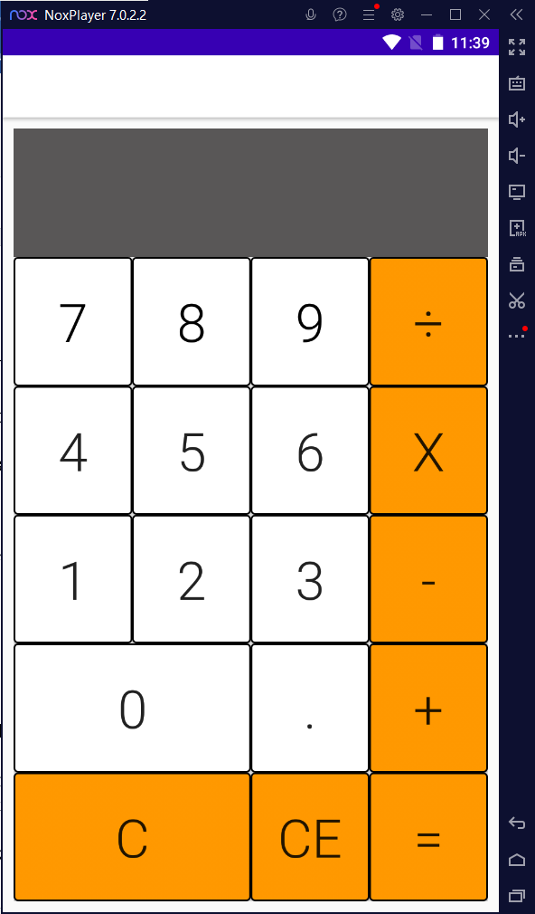

* Button:
* Numeric Buttons: “0”, “1”, “2”, “3”, “4”, “5”, “6”, “7”, “8”, “9”.
* Calculation Buttons: “+”, “-”, “x”, “/”.
* Decimal Button: “.”.
* Button “Answer”.
* Button “C”.
* Button “CE”.
* The display shows the calculation and the result.

1. **THE FEATURES OF CALCULATER:**
2. **Initialize input data:**

* Initialize variables to hold data from buttons.
* The data of the buttons from 0 -> 9 is in text form, so it is necessary to convert the data accordingly.

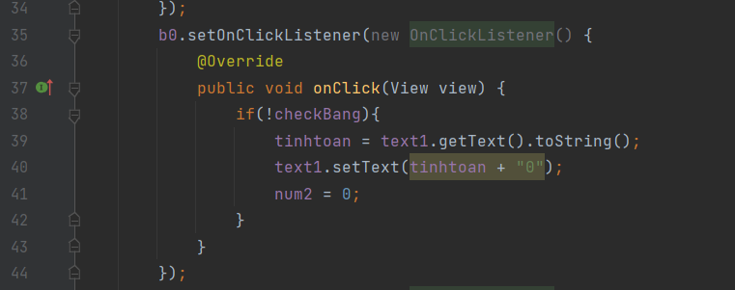

* Because buttons are inherited objects of the view interface, it is necessary to retrieve the search by id.
* Một số biến đặc biệt như “pheptoan” để thể hiện sự kiện hiện tại là của phép toán nào. Ngoài ra còn có các biến điều kiện để kiểm tra như checkDot, pheptoan2, checkBang.

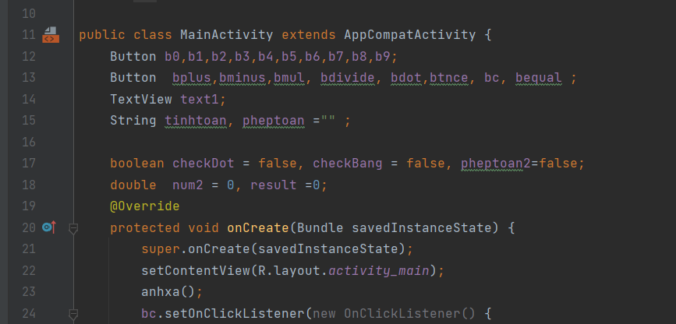

**Example:**

**b0** = (Button) findViewById(R.id.***b0***);

### **Algorithms ideas:**

* Data button: Create a method “anhxa” to start all data buttons.

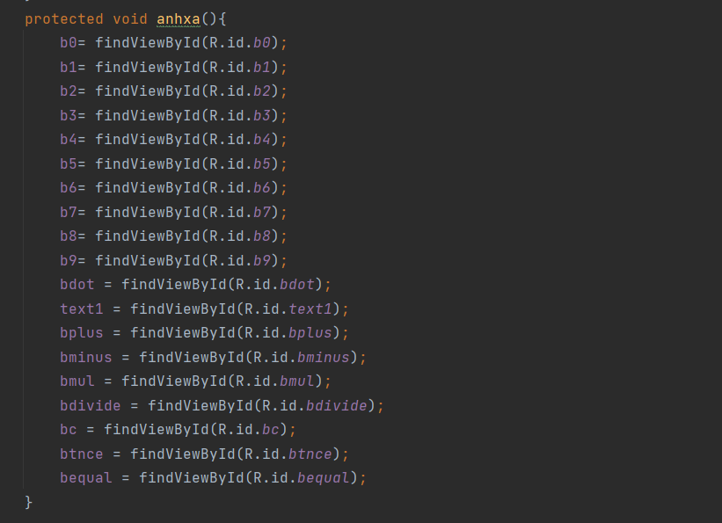

* Function Buttom:
* For math buttons, steps need to be performed:

+ Is the current data type null?.

+ Check if the operation is the 2nd operation or not.

+ If both of the above conditions are not met, then execute the receive data from the screen into num2, then turn on the flag “pheptoan” and “pheptoan2”.

* Bplus:
* Check if input condition is first calculation or not (null): Use variable assignment num2 = 0 and values ​​"pheptoan2" = true to check if performing operations continuously
* Perform a check to see if the operation is continuous: Take the data num2 and add to the current result
* Calculation with input value (num1): Set the memory variable result equal to the result displayed on the current screen and the operation "+" to wait for execution when the bequal event is executed.

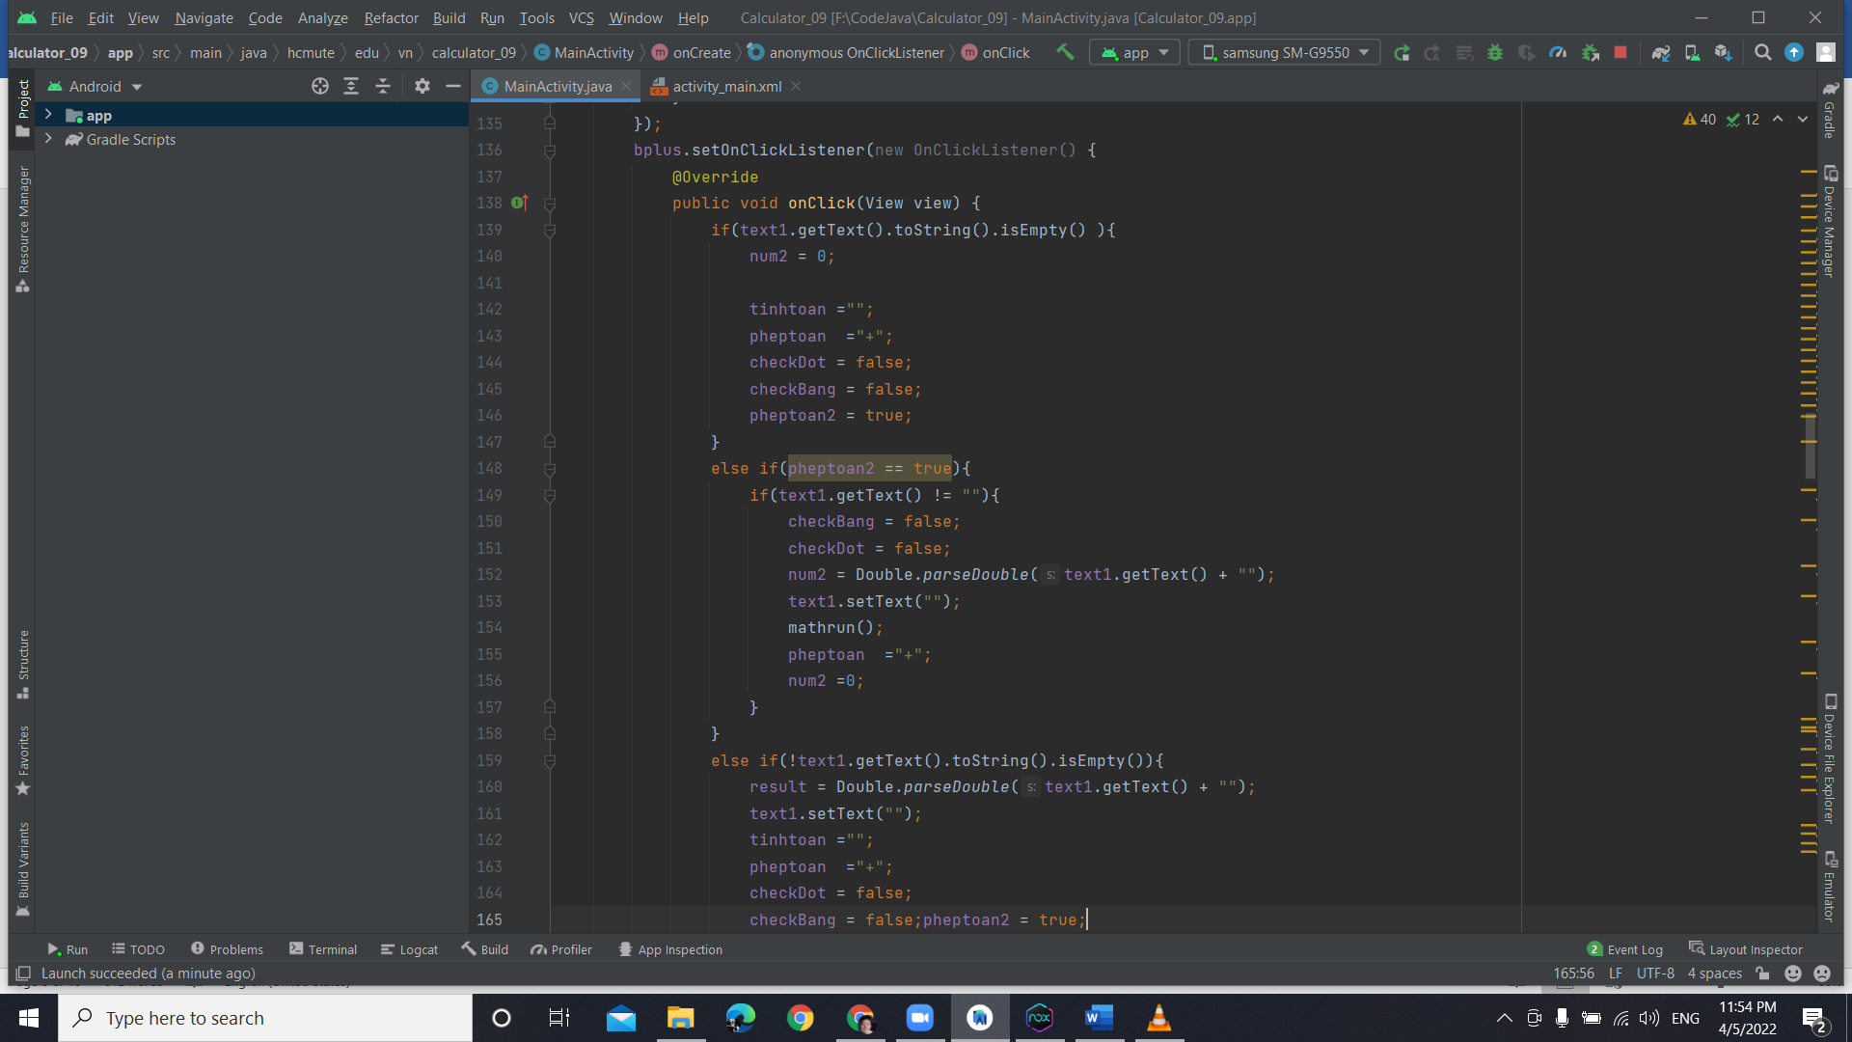

* Bminus button: Execution similar to the plus button but only the value assigned to the variable "pheptinh" is “-”

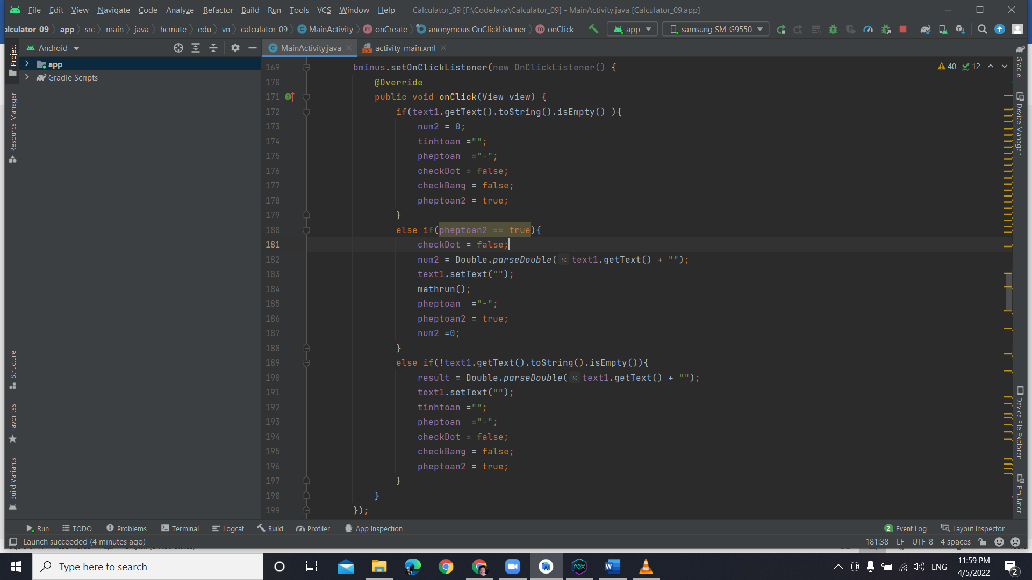

* Bdivide button: Execution similar to the plus button but only the value assigned to the variable "pheptinh" is “/”.

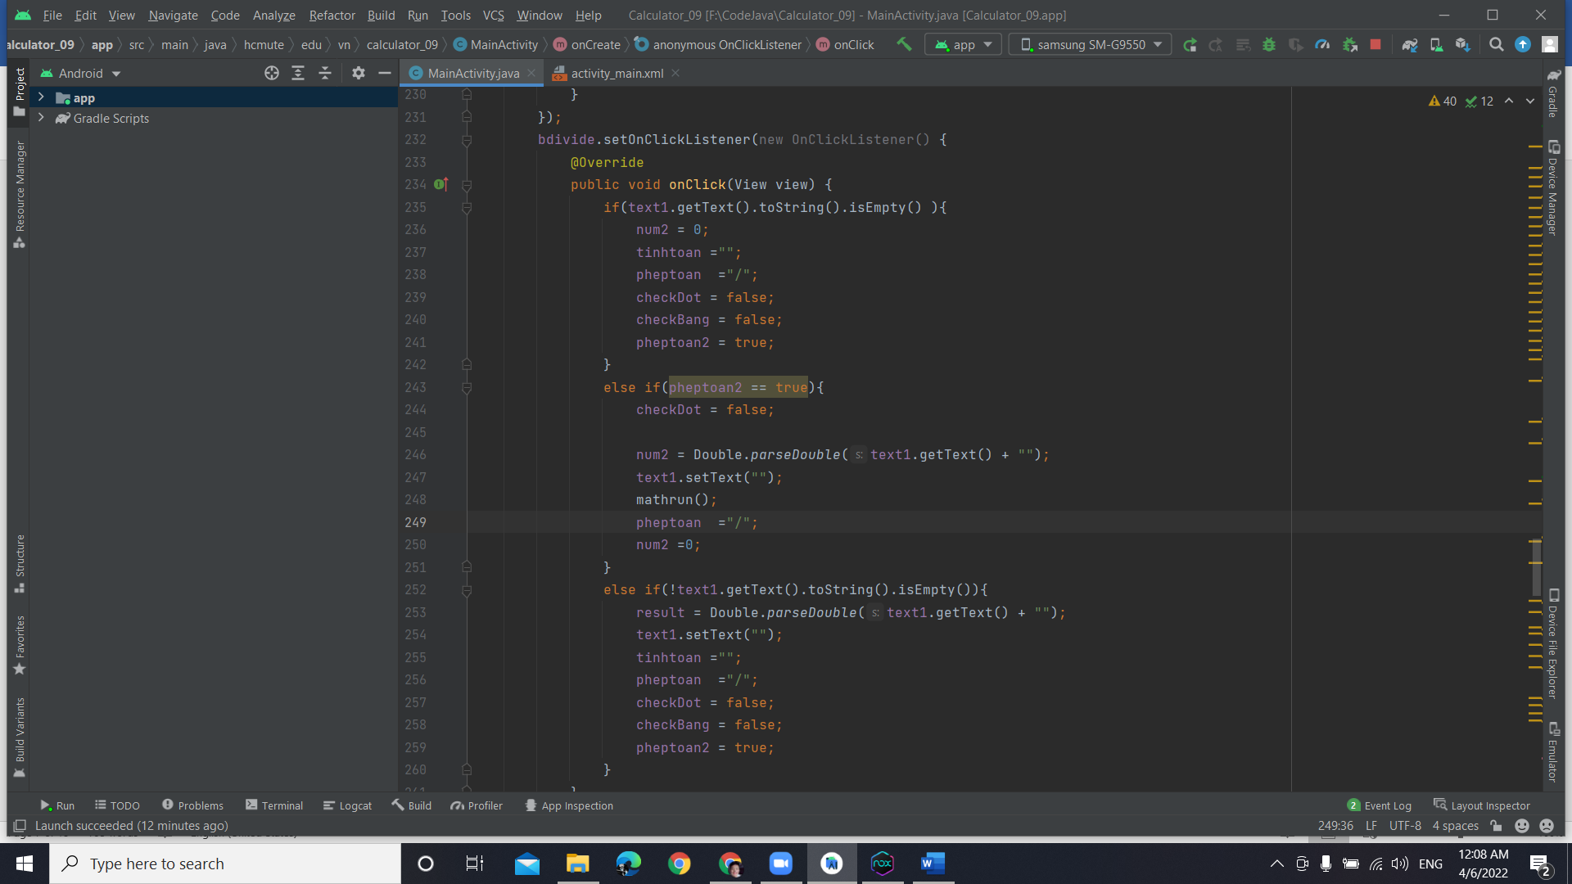

* Bmul button: Execution similar to the plus button but only the value assigned to the variable "pheptinh" is “*”.

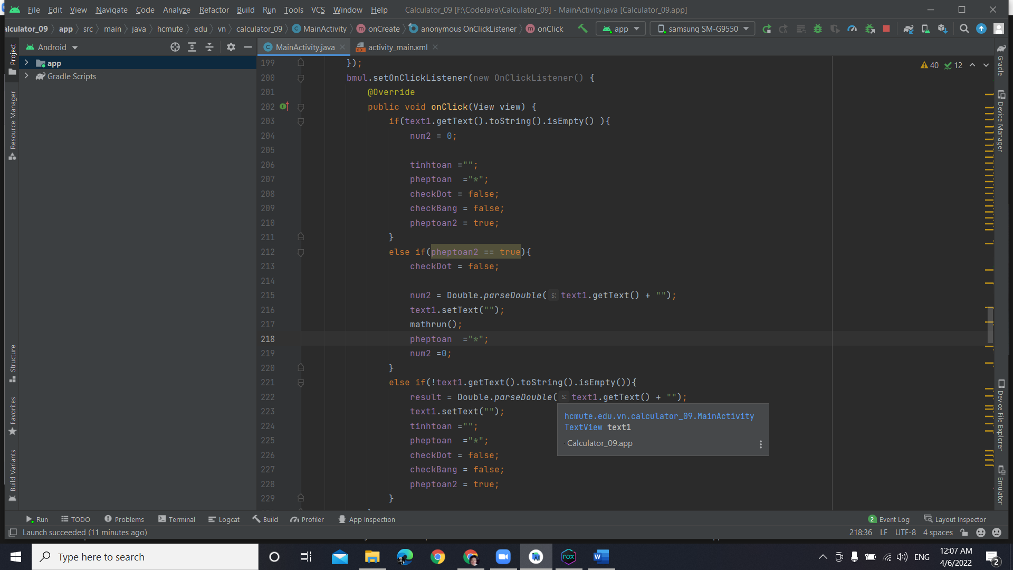

Use mathrun() to do the corresponding maths based on "pheptoan"

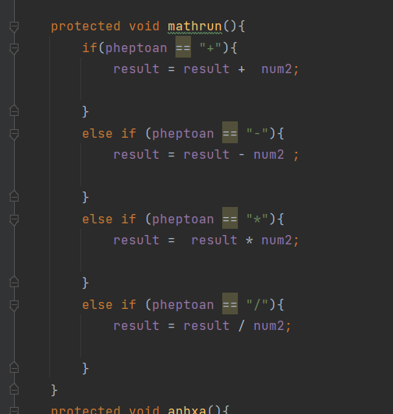

* Equals button “=”: Implement “pheptoan” pennant-based computation by converting string to double data type and calculating with result.

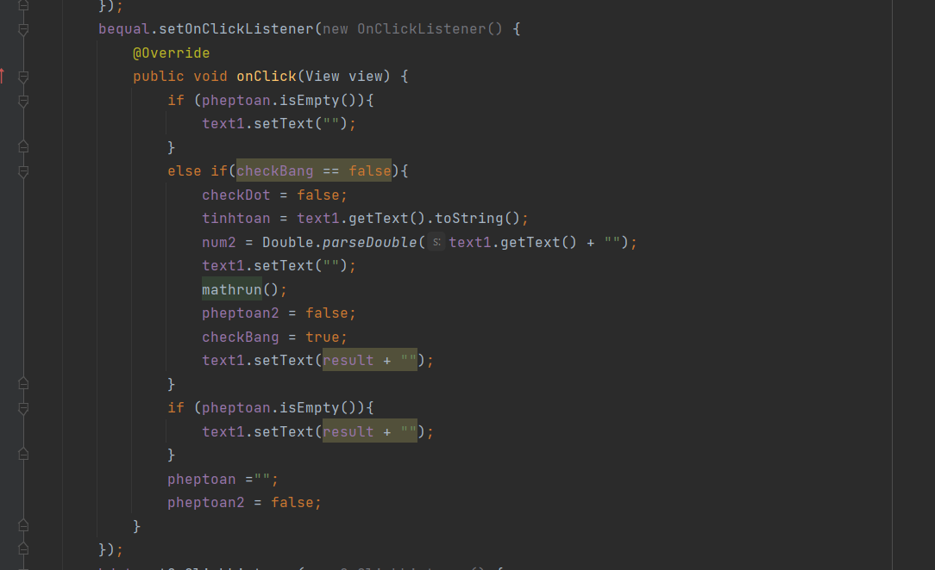

* CE button: The idea is to perform the removal of the last character of the string by “length() – 1”.

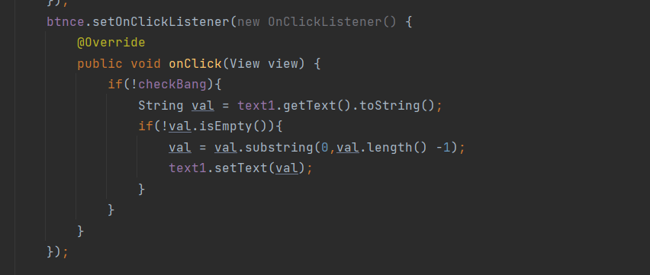

* C button: Return all execution information to the initial state.

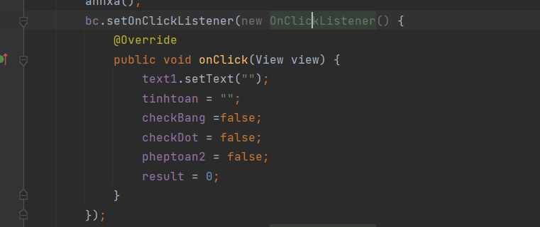

1. **Other function buttons:**

* The Dot button is used to assign the "." into the string and then "checkDot=true".

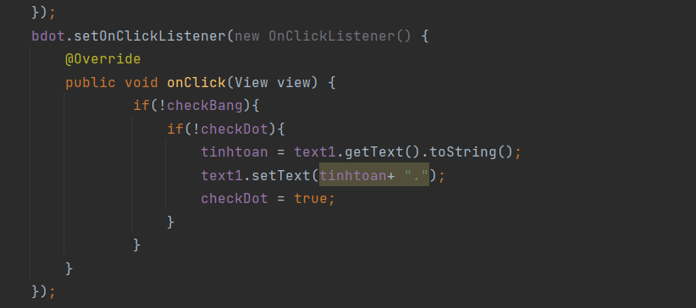

* Perform multiple operations without pressing the equal sign.
* Handle exceptions like when user initialization clicks function buttons but not number buttons.
* When the user presses a function button many times, only one button is received.

1. **Demo result:**

* Input data:

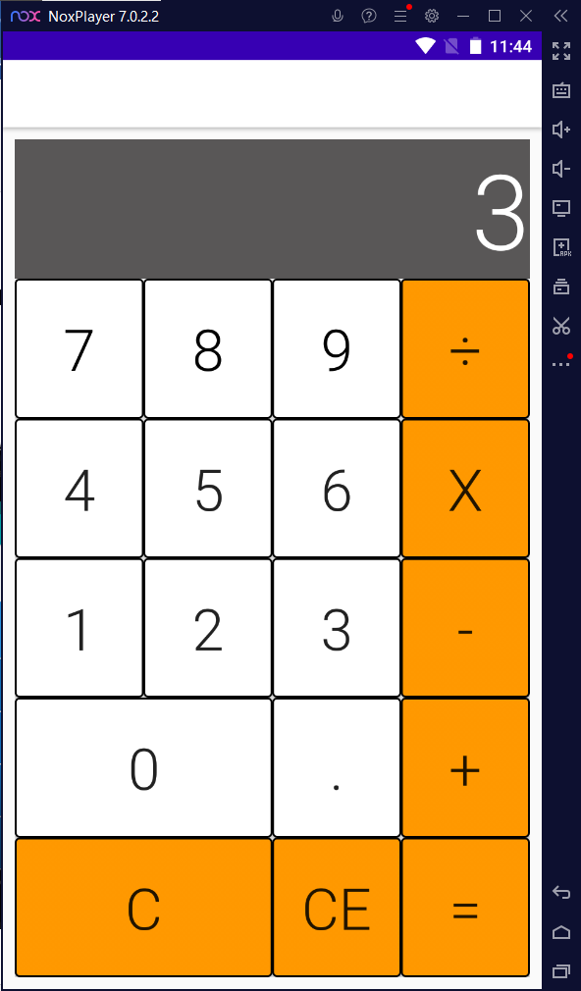 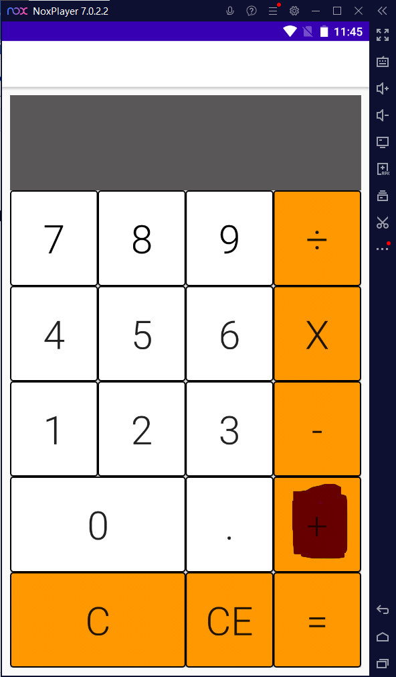

- Input processing, if initially inputting numbers, will assign and execute sequentially if input is a calculation that will initialize the variable result = 0 (for later calculation with num2).

* Calculate:

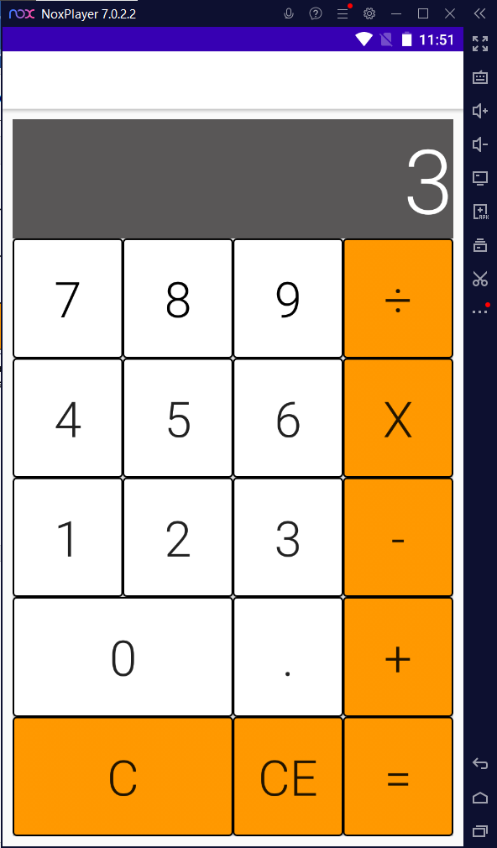

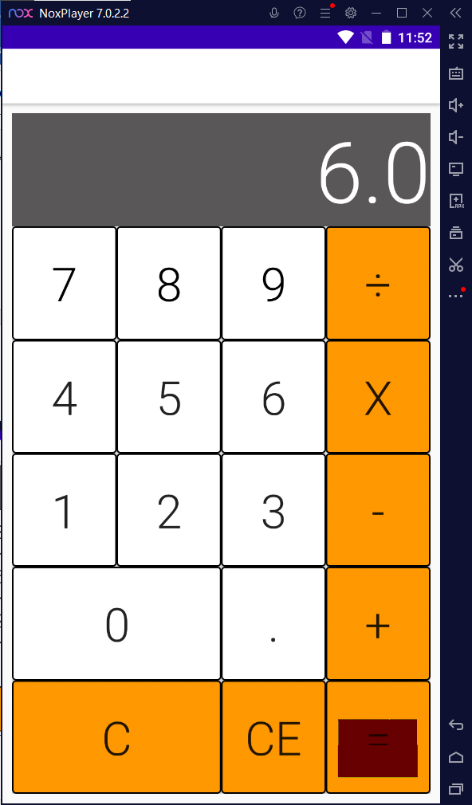

* Starting from the calculation:

Single calculation calculation: + 1 = 1 (0 + 1 = 1)

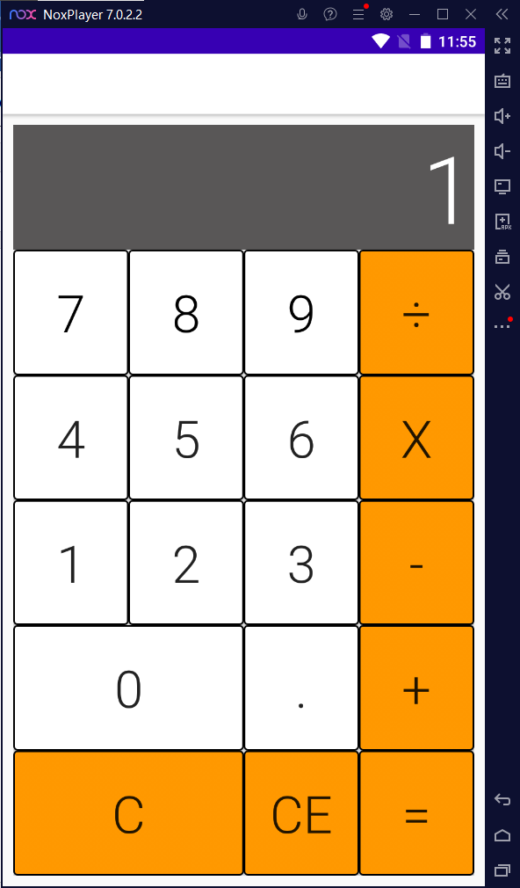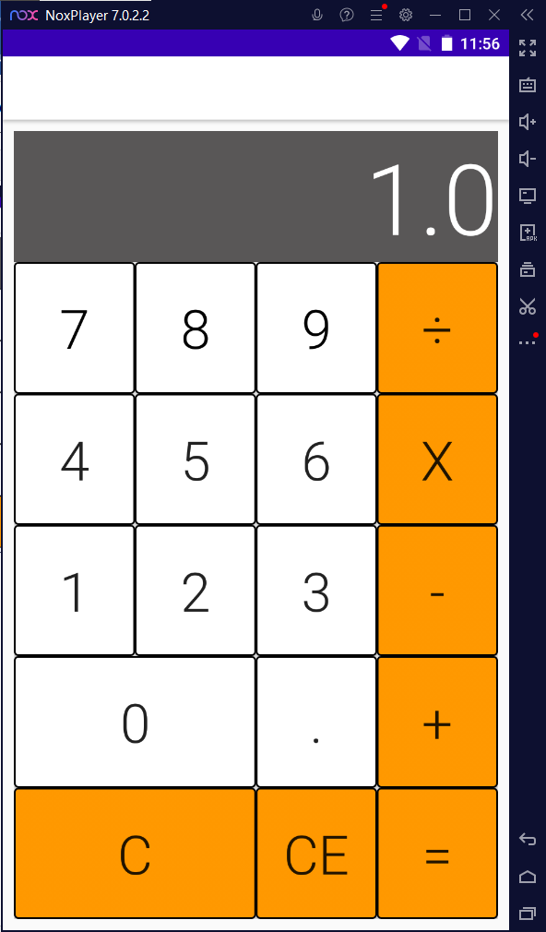

Multi-calculation: Ex 1 +1 +1 = 3

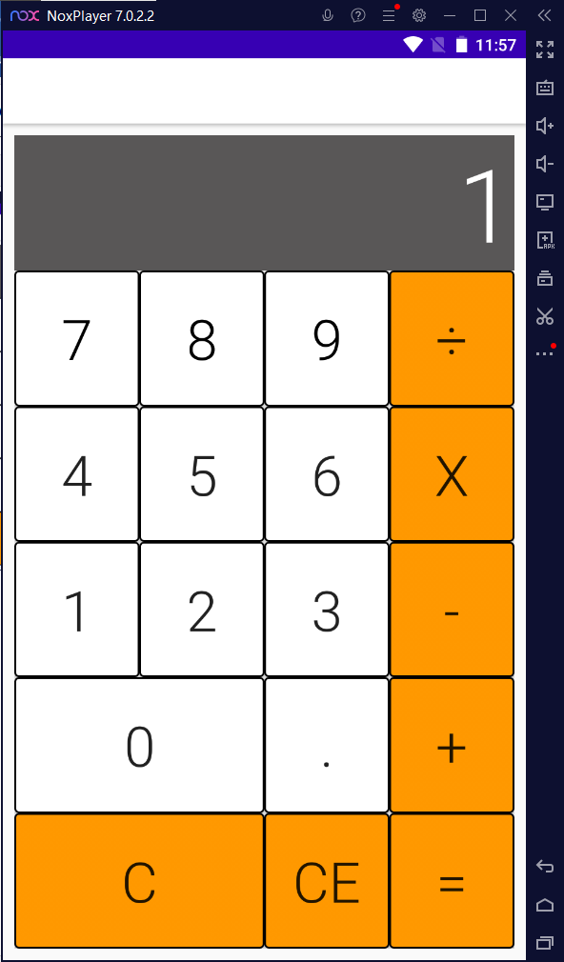 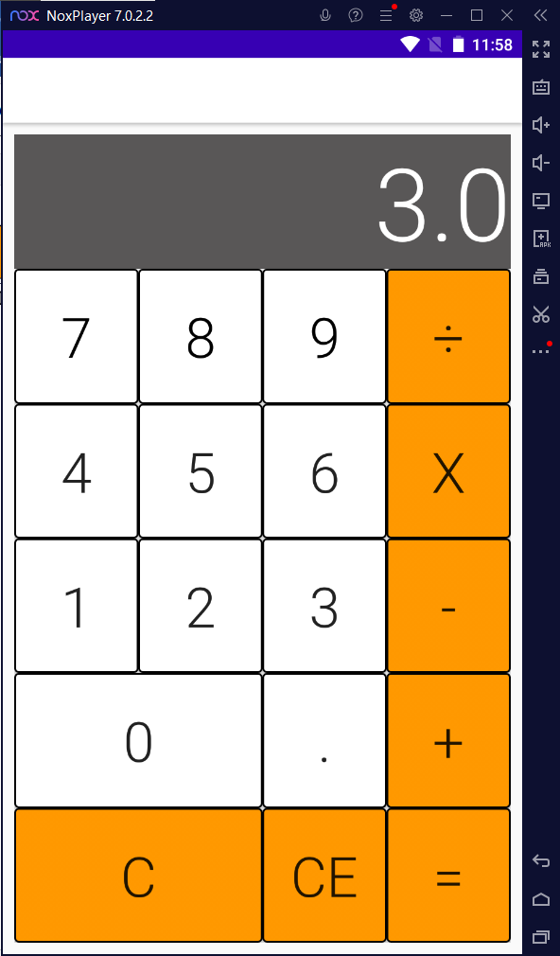

* Delete all: C Button

 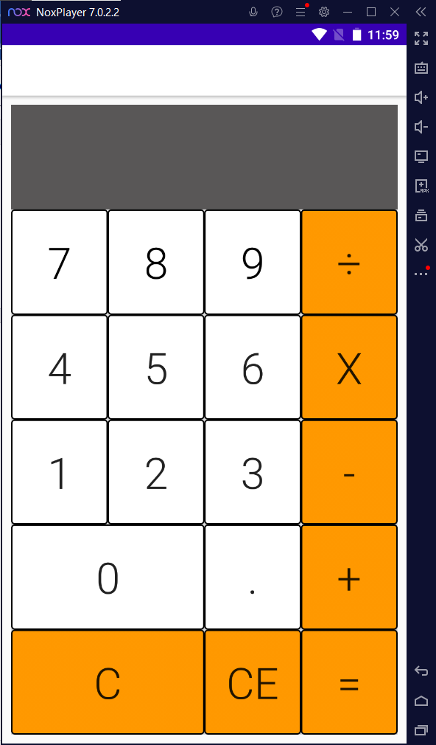

* Delete 1 character:

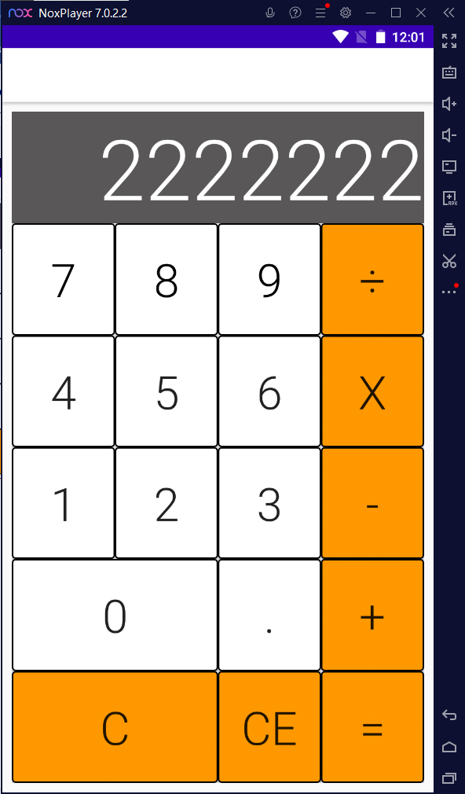 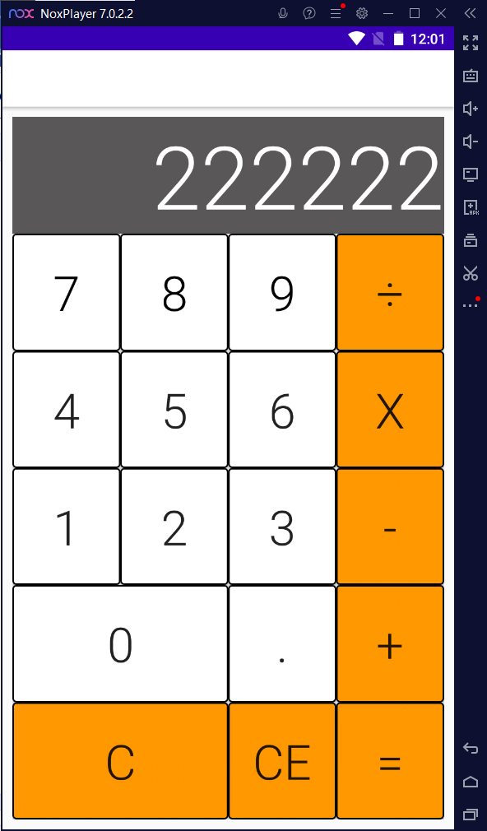

* Dot Button:

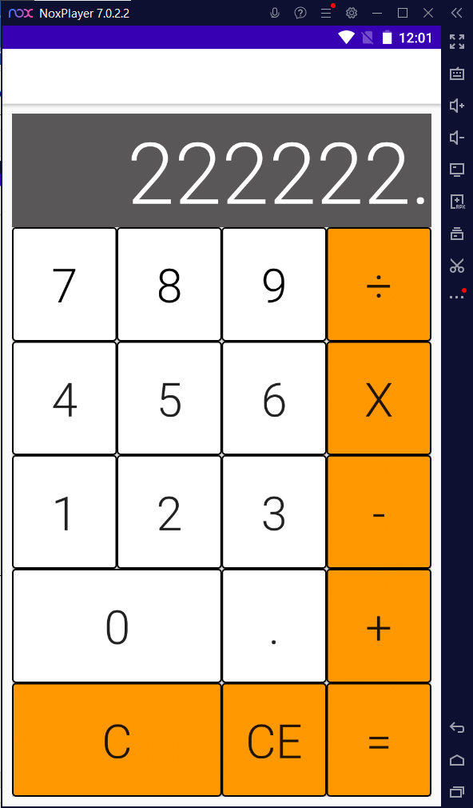

# ***Task Distribution***

|  |  |  |  |  |
| --- | --- | --- | --- | --- |
| Task | Taken by | Requirement/purpose | % Done | Result |
| Writing UI Programs and Using Data’ button | Phạm Minh Hiếu | Calculator | 100% | Done |
| Solve problem and Write Report | Phạm Văn Mạnh Hùng | Calculator | 100% | Done |